Guided Practice Report
Before completing this guided practice report, you should have completed the associated procedure.

Screenshots
After you have completed the procedure for the guided practice, add your screenshots below.

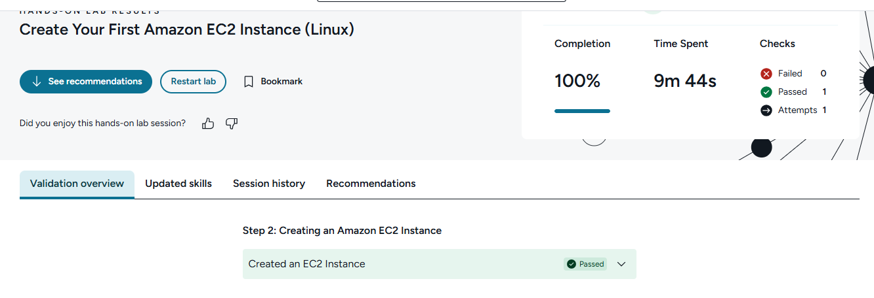

Reflection Questions
After you have completed the procedure for the guided practice, provide your answers to the reflection questions here.
Why is the creation of a Secure Shell (SSH) public/private key pair important for managing AWS EC2 instances?
It securely proves you are allowed to access the EC2 instance. The public key goes on AWS, and you keep the private key safe. No private key, no login key to the castle.
What is the role of tags as they relate to AWS EC2 instances?
Tags are labels for EC2 instances, like Name, Project, or Owner. They help organize, search, track costs, and manage resources.
Why is it important to terminate EC2 instances (or other AWS services) when they are not in use?
AWS charges for running resources. Terminating unused EC2 instances prevents surprise bills, reduces security risks, and keeps your cloud environment tidy.

